1 which of the following is not the part of CPU

1 ALU

2 RAM

3 CU

4 1AND 3 BOTH

Ans RAM

2 what is the Function of ram in a computer

Ans RAM (Random Access Memory) is a critical component in a computer that serves several important functions:

**1. Temporary Data Storage**

RAM stores data that is currently being used or processed by the CPU. This includes:

* Operating system files in use
* Open applications
* Active files and documents

Because it's much faster than hard drives or SSDs, this helps the system run quickly and smoothly.

**2. Fast Read/Write Access**

RAM allows the CPU to read and write data much faster than from other storage like HDDs or SSDs. This improves:

* Program loading times
* Overall system responsiveness
* Multitasking efficiency

**3. Supports Multitasking**

More RAM allows you to run more programs simultaneously without slowing down. For example, you can browse the web, stream music, and edit a document all at once.

**4. Caches Frequently Used Data**

RAM keeps frequently accessed data readily available, reducing the need to fetch it repeatedly from slower storage.

**5. Handles Background Processes**

Operating systems use RAM to manage background tasks (e.g., updates, drivers, notifications) without affecting the performance of active applications.

3 Which of the following is a primary storage device

1 HDD

2 SSD

3 SD CARD

4 1 AND 2 BOTH

ANS 1 AND 2 BOTH

4 What is the purpose of GPU

ANS The **GPU (Graphics Processing Unit)** is a specialized processor primarily designed to handle **graphics rendering** and **visual output**. Here's a breakdown of its main purposes:

**1. Rendering Graphics and Images**

* The GPU renders images, videos, and animations for display on your monitor.
* It's responsible for tasks like:
  + Drawing UI elements
  + Playing videos
  + Powering game graphics

**2. Gaming**

* Modern video games rely heavily on the GPU to:
  + Render complex 3D environments
  + Handle lighting, shadows, textures, and motion
  + Maintain high frame rates and smooth visuals

**3. Accelerating Graphical Software**

* Many creative and design programs use the GPU for better performance:
  + **Photoshop** (image editing)
  + **Premiere Pro** (video editing)
  + **Blender** (3D modeling)
  + **CAD software** (engineering/design)

**4. Parallel Processing for Non-Graphics Tasks**

* GPUs have hundreds or thousands of cores, making them ideal for tasks requiring massive parallel processing, such as:
  + **Machine learning and AI**
  + **Cryptocurrency mining**
  + **Scientific simulations**
  + **Data processing (like video encoding)**

**5. Offloading Work from the CPU**

* By handling visual and parallel tasks, the GPU frees up the CPU to focus on other operations, making the entire system faster and more efficient.

SECTION 2 True or False

5 The motherboard is the man circuit board of a computer where others components are attached

ANS TRUE

6 A UPS is a hardware device that provides emergency power to a load when the input power source fails

ANS TRUE

7 An expansion card s a circuit board that enhances the functionality of a component

ANS TRUE

SECTION 3 Short Ans

8 Explain the difference between HDD and SSD

ANS **1. How They Work**

* **HDD**: Uses spinning magnetic disks (platters) and a moving read/write arm to access data.
* **SSD**: Uses flash memory (like a USB drive) to instantly read/write data.

**2.Speed**

* **HDD: Slower (typically 50–120 MB/s read speed)**
* **SSD: Much faster (500 MB/s to several GB/s)**

**Result: SSDs boot your system and load files/apps in seconds. HDDs take longer.**

**3.Durability**

* **HDD: More prone to damage due to moving parts.**
* **SSD: More resistant to shock and wear (no moving parts).**

**4.Noise**

* **HDD: Can be noisy (spinning and clicking sounds)**
* **SSD: Completely silent**

**5. Cost**

* **HDD: Cheaper per GB**
* **SSD: More expensive, but prices are dropping**

**9 Describe the function of bios in a computer system**

**ANS What is BIOS?**

**BIOS (Basic Input/Output System) is a small program built into your computer’s motherboard. It helps your computer start up and get ready to use.**

**s Functions of BIOS (in simple language)**

1. **Checks the Computer When You Turn It On**
   * **BIOS makes sure all the important parts (like the keyboard, memory, and hard drive) are working properly.**
   * **If something is wrong, it will show an error or make beeping sounds.**
2. **Starts the Operating System**
   * **BIOS looks for the hard drive or SSD with Windows (or other OS) on it.**
   * **Then it starts the operating system so you can use the computer.**
3. **Sets Up the Hardware**
   * **BIOS helps the computer know how to use things like the mouse, keyboard, and display before the operating system takes over.**
4. **Lets You Change Settings**
   * **You can press a key (like F2 or Del) when the computer starts to enter the BIOS Setup.**
   * **From there, you can change settings like:**
     + **The order in which the computer checks for drives (boot order)**
     + **The system time and date**
     + **Passwords for security**

**10 List briefly explain three input devices commonly used with computers**

**ANS Here are three common input devices used with computers, briefly explained:**

**1. Keyboard**

* **Function: Used to type letters, numbers, and commands.**
* **Example: Typing documents, entering passwords, using shortcut keys.**

**2. Mouse**

* **Function: Moves the pointer on the screen and selects items by clicking.**
* **Example: Clicking icons, dragging files, selecting text.**

**3. Scanner**

* **Function: Converts physical documents or photos into digital format.**
* **Example: Scanning a paper document to save it as a PDF.**

**Section 4 Practical application**

**11 Identify and label the following components on a diagram of motherboard**

**1 CPU**

**2 RAM SLOTS**

**3 SATA CONNECTORS**

**4 PCI-E SLOT**

**1 CPU**

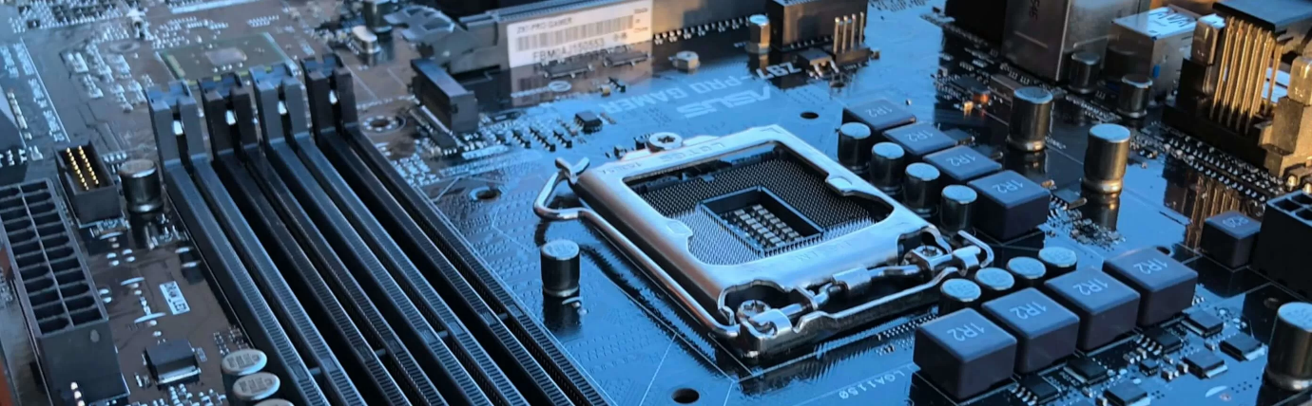

**CPU**

**2 RAM SLOTS**

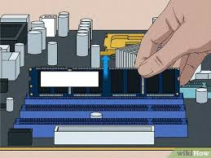

**RAM SLOTS**

**3 SATA CONNECTORS**

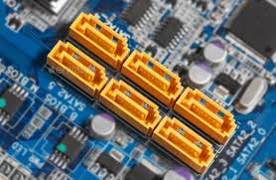

**SATA CONNECTORS**

4 PCI-E SLOT

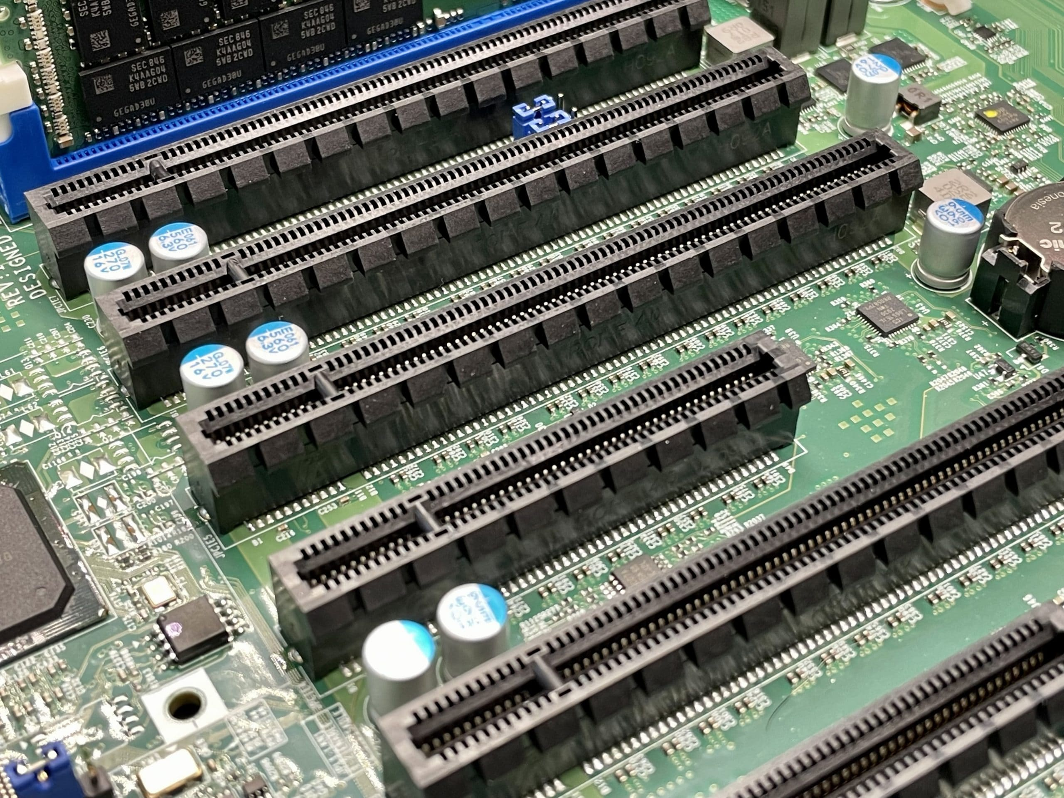

PCI-E SLOT

12 Demonstrate how to install ram module into a computer

ANS **What You’ll Need:**

* A compatible **RAM module**
* A **desktop computer**
* A **non-static surface** or **anti-static wrist strap** (to prevent damaging parts)

**Steps to Install RAM in a Desktop Computer:**

**1. Turn Off the Computer and Unplug It**

* Shut down the PC.
* Unplug the power cable and all connected devices.

**2. Open the Computer Case**

* Use a screwdriver (if needed) to open the side panel of the computer case.

**3. Ground Yourself**

* Touch a metal part of the case or wear an **anti-static wrist strap** to prevent static electricity from damaging components.

**4. Locate the RAM Slots**

* Look for long slots near the CPU on the motherboard (usually 2 or 4 slots).
* These are called **DIMM slots**.

**5. Prepare the RAM Slot**

* Push the small plastic clips on both ends of the slot **outward** to open them.

**6. Align the RAM Module**

* Hold the RAM by the edges.
* Match the **notch** in the RAM stick with the **ridge** in the slot (it only fits one way).

**7. Insert the RAM**

* Press the RAM **firmly and evenly** into the slot.
* The clips should **snap into place** on their own when it’s fully inserted.

**8. Close the Case and Reconnect Everything**

* Screw the side panel back on.
* Plug in your power cable, monitor, keyboard, etc.

**9. Turn on the Computer**

* The system should detect the new RAM automatically.
* You can check it by going to:
  + **Windows**: Right-click on This PC > Properties or open **Task Manager > Performance > Memory**

Section 5 ESSAV

13 Discuss the importance of proper cooling mechanisms in a computer system include example of cooling methods and their effectiveness

ANS **Importance of Proper Cooling Mechanisms in a Computer System**

Proper cooling is **essential** in a computer system because it helps maintain **safe operating temperatures** for components such as the CPU, GPU, motherboard, and power supply. Without adequate cooling, your system can suffer from:

**Why Cooling Is Important:**

1. **Prevents Overheating**
   * High temperatures can cause components to overheat and malfunction.
   * Overheating can lead to system crashes, shutdowns, or permanent damage.
2. **Maintains Performance**
   * Modern CPUs and GPUs slow down automatically (thermal throttling) when they get too hot to avoid damage, which reduces performance.
3. **Improves Hardware Lifespan**
   * Cooler components last longer. Excess heat accelerates wear and tear on electronics.
4. **Supports Overclocking**
   * Users who boost CPU or GPU speeds (overclocking) need extra cooling to handle the increased heat.
5. **Ensures System Stability**
   * A well-cooled system is more reliable and stable, especially under heavy loads like gaming or video editing.

**Examples of Cooling Methods & Their Effectiveness:**

| **Cooling Method** | **Description** | **Effectiveness** | **Common Use** |
| --- | --- | --- | --- |
| **Air Cooling** | Uses fans and heatsinks to blow air over hot components. | Good for  general use | Most desktops & laptops |
| **Liquid Cooling** | Circulates coolant through tubes and a radiator to transfer heat. | Very effective, especially for high-performance systems | Gaming PCs, workstations |
| **Thermal Paste** | Paste between CPU and heatsink to improve heat transfer. | Essential but not a standalone cooler | All CPUs and GPUs |
| **Passive Cooling** | Uses metal heat sinks without fans, relying on natural airflow. | Less effective, silent | Low-power devices (e.g., routers) |
| **Phase-Change Cooling** | Uses refrigeration to cool components below room temperature. | Extremely effective but expensive | High-end enthusiast setups |
| **Liquid Nitrogen (LN2)** | Extreme cooling for short bursts (e.g., record overclocking) | Not practical for daily use | Competitive overclocking only |

**Summary:**

Proper cooling is **crucial** for:

* Protecting components from damage
* Keeping the system stable and fast
* Enabling advanced features like overclocking

**Common effective setups** include:

* **Air cooling** for everyday use
* **Liquid cooling** for high-performance tasks

**14 Explain the concept of bus width and its significance in a computer architecture**

ANS **Bus width** refers to the number of bits a computer system can transmit **simultaneously** through its data bus. It defines how much **data** can travel **in or out of the CPU** at one time.

Think of it like the number of lanes on a highway — more lanes (wider bus) means more cars (data) can travel at the same time.

**🔄 Types of Buses in a Computer**

There are different types of buses, each with its own width:

| **Type of Bus** | **Purpose** |
| --- | --- |
| **Data Bus** | Transfers actual data between CPU, memory, and devices |
| **Address Bus** | Carries memory addresses (locations) |
| **Control Bus** | Carries control signals (read/write, etc.) |

**📏 What Does Bus Width Measure?**

* A **32-bit bus** can carry **32 bits** of data at a time.
* A **64-bit bus** can carry **64 bits** at a time — doubling the amount of data moved.

**💡 Significance of Bus Width**

| **Feature** | **Impact** |
| --- | --- |
| **Speed** | Wider buses transfer more data at once, improving speed. |
| **Performance** | A larger bus width means the CPU can process and move more data in a single clock cycle. |
| **System Capability** | It defines how much memory a system can access — e.g., a 32-bit system can access up to 4 GB RAM, while 64-bit can access much more. |
| **Compatibility** | Software and operating systems must match the bus width (e.g., 64-bit OS on a 64-bit bus). |

**✅ Example:**

* A **64-bit CPU** with a **64-bit data bus** can transfer **8 bytes (64 bits)** of data at once.
* If the memory clock is **1600 MHz**, and it's transferring 64 bits per cycle, the theoretical bandwidth increases.